CS 193
Joonyoung Seo
Nov 1 2026

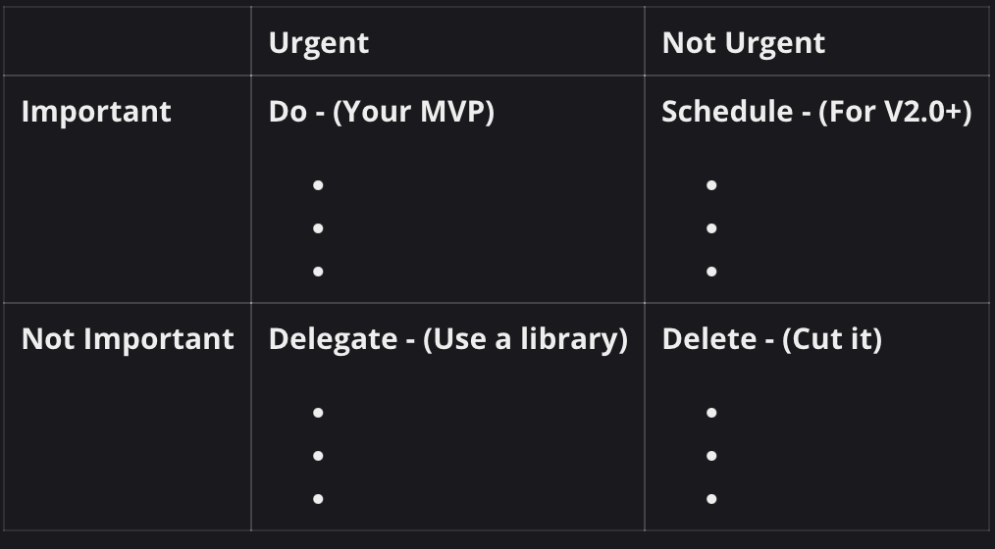

NetTrace — Eisenhower Matrix

DO — Important & Urgent (MVP / Version 1.0)
- Network Connectivity Monitoring: Continuously check network connectivity and measure latency to a local gateway and an external server.
- Connection Failure Detection: Detect and record connection timeouts, failed probes, and significant latency spikes.
- Network Event Logging: Save timestamps, latency measurements, and connection failures to CSV files for later analysis.
- Basic Wi-Fi Benchmarking and Comparison: Calculate average latency, jitter, and connection failure rates, and compare results collected from different Wi-Fi networks.
--------------------------------------------------------------------------------------------------------

SCHEDULE — Important & Not Urgent (Version 2.0+)
- Graphical User Interface (GUI): Develop a desktop dashboard to display network statistics and diagnostic results.
- Advanced Network Diagnostics: Analyze additional network information to provide more detailed explanations of possible connection problems.
- Automatic Wi-Fi Information Collection: Collect SSID, signal strength, frequency band, and access point information when available.
--------------------------------------------------------------------------------------------------------

DELEGATE — Not Important & Urgent (Use Existing Libraries or Tools)
- Network Communication: Use Java’s built-in networking APIs and macOS networking utilities instead of implementing low-level networking protocols.
- Build and Dependency Management: Use Gradle to manage project dependencies, compilation, and execution.
- Automated Testing: Use JUnit 5 for testing instead of building a custom testing framework.
--------------------------------------------------------------------------------------------------------

DELETE — Not Important & Not Urgent (Out of Scope)
- Built-in VPN Service: Creating a VPN or routing service is unnecessary for diagnosing network stability.
- AI-Powered Network Diagnosis: Developing a machine learning model to predict network failures would add unnecessary complexity.
- Cloud-Based Monitoring Platform: Hosting network data on a remote server is unnecessary for a local diagnostic application.

